PRACTICAL – 04
NAME: Aryan Kashikar
ROLL NO.: D2 - 32

Aim : Execution of various types of joins operations on multiple tables in a database
SAILOR :
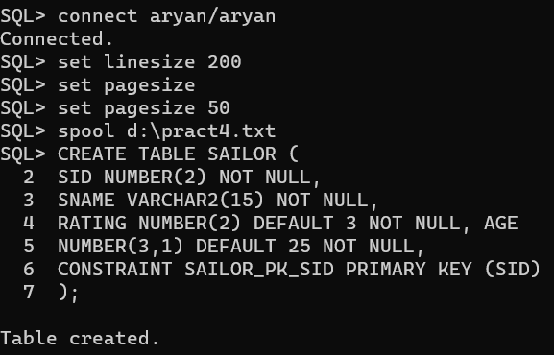
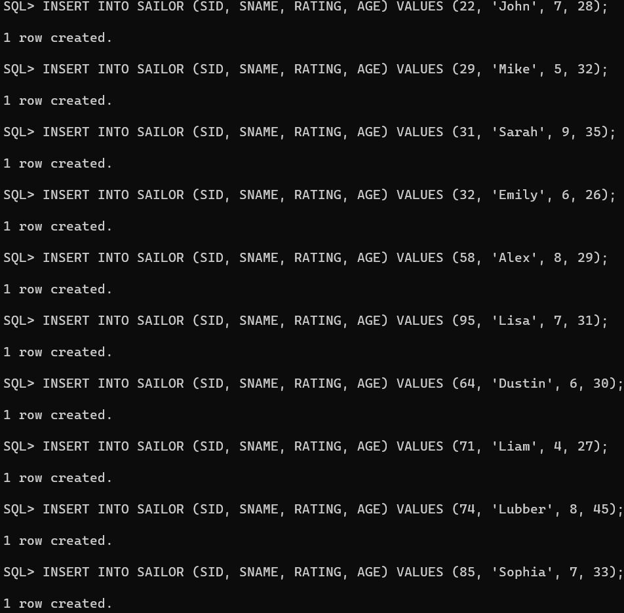
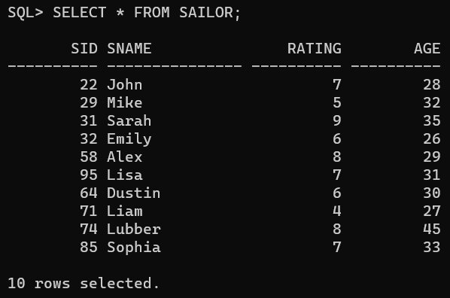

BOAT:
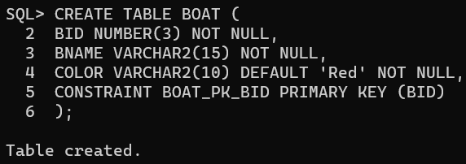
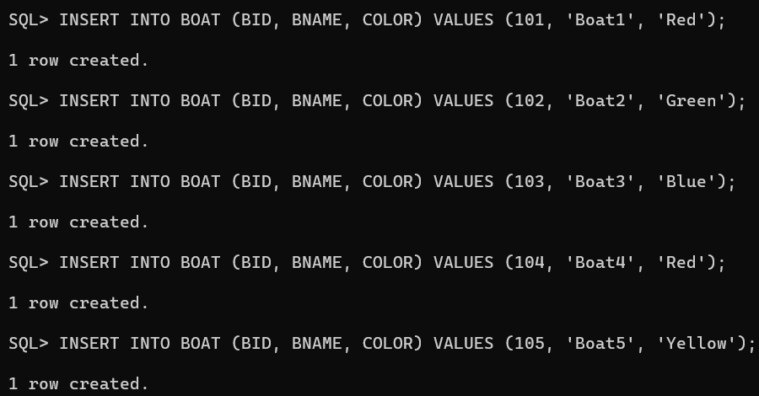
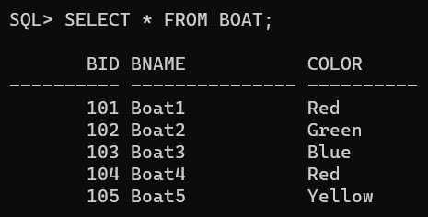

RESERVE:
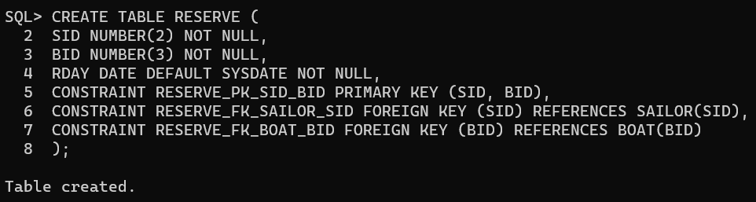
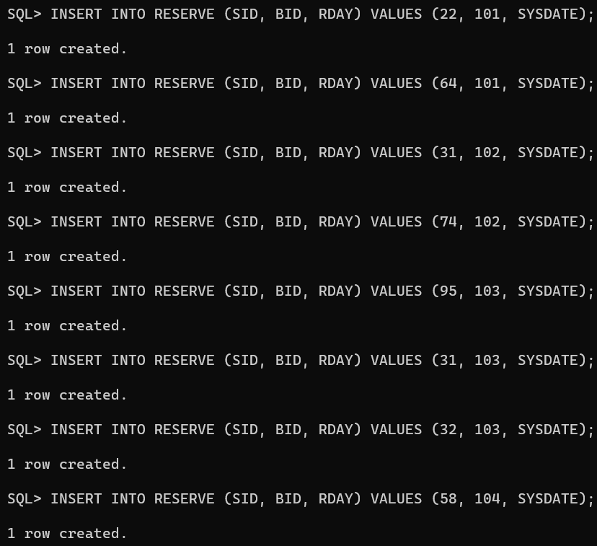
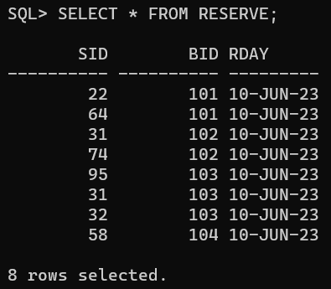
Tasks:
- CREATE VIEW SAILOR1 with SID [22, 29, 31, 32, 58, 95]
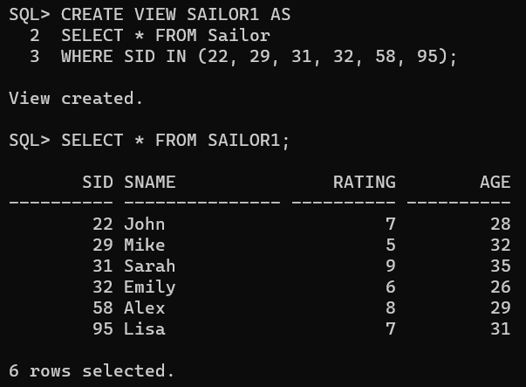

- CREATE VIEW SAILOR2 with SID [31, 32, 64, 71, 74]
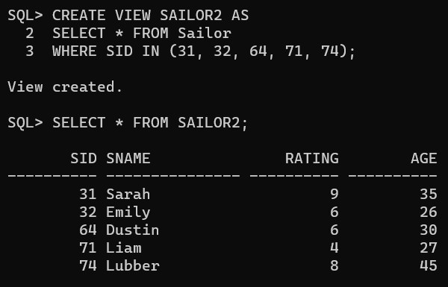
- CREATE VIEW SAILOR3 with SID [22, 32, 85, 74]
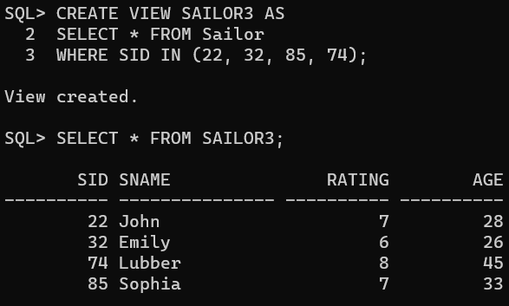

- CREATE VIEW RESERVE1 with SID [22,64]
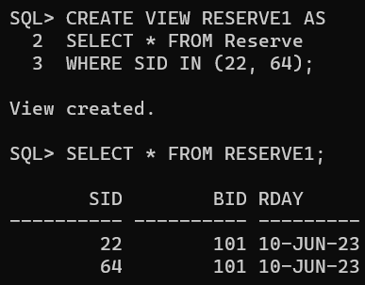

- CREATE VIEW RESERVE1 with SID [31,74]
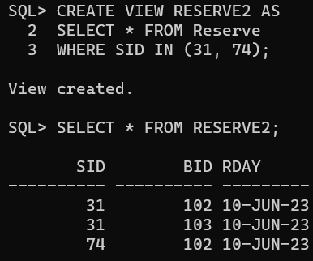

- Display the content of above views
ALREADY DONE IN THE ABOVE QUERIES.

- Perform Inner Join Sailor and Reserve table and display all the attributes.
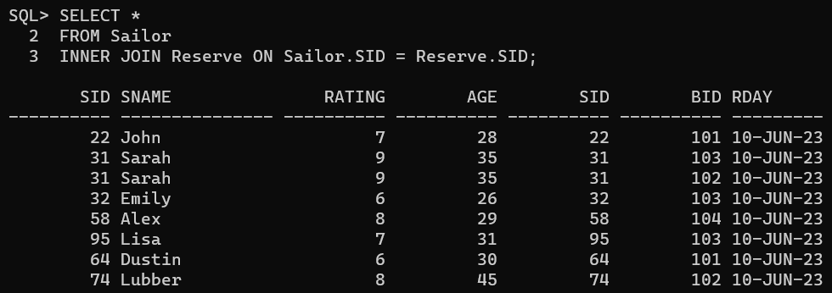

- Perform Inner Join Sailor and Reserve table and display only Sid and Sname from sailors table and Bid and Rday from Reserve table.
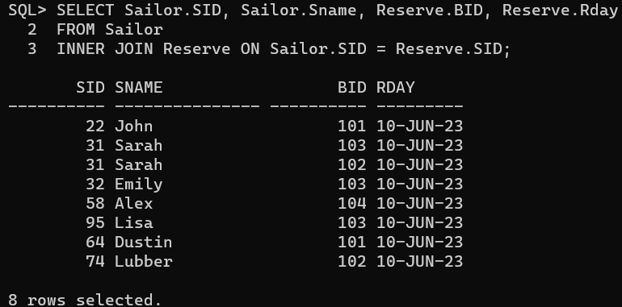

- Perform Equi Join Sailor and Reserve table and display only Sid and Sname from sailors table and Bid and Rday from Reserve table. The reservation month should be November and SID should be 74.
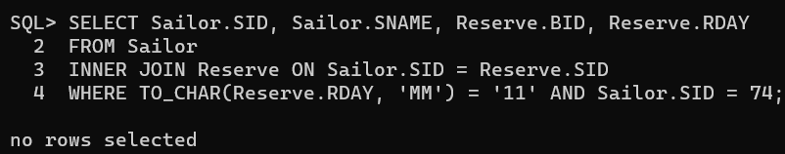
- Perform Theta join Sailor, Reserve and Boat. The reservation month should be August and BID should not be 101.
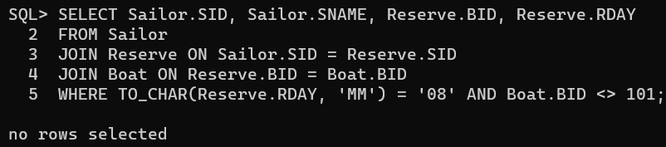

- Perform Left Outer Join on Sailor1 and Sailor2 and tuples to be ordered by SID of sailor1 and sailor2.
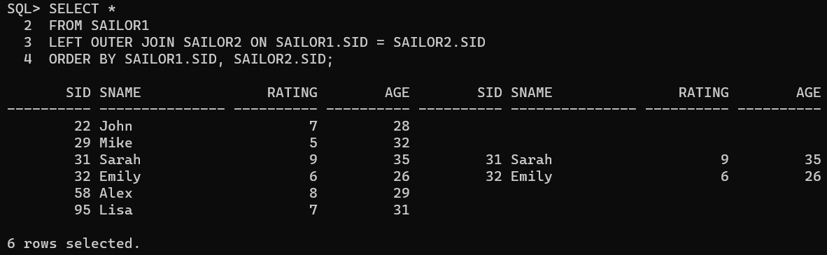

- Perform Right Outer Join on Sailor1 and Sailor2 and tuples to be ordered by SID of sailor1 and sailor2.
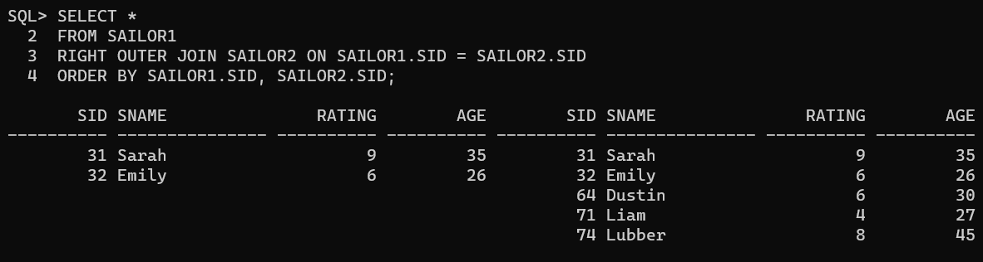

- Perform Full Outer Join on Sailor1 and Sailor2 and tuples to be ordered by SID of sailor1 and sailor2.
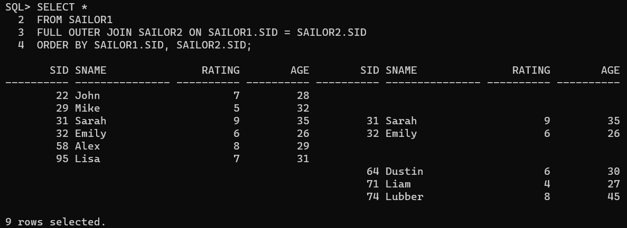
- Execute Natural Join on Sailor and Reserve
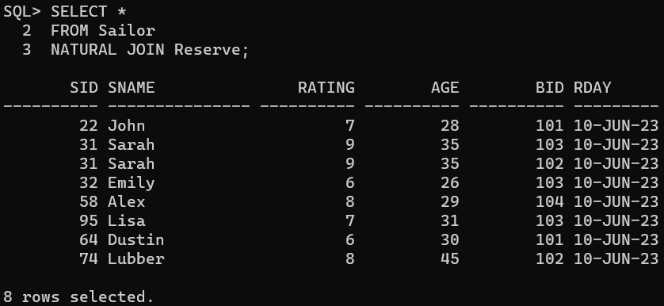

- Perform Cross Join on Sailor3 and Reserve2
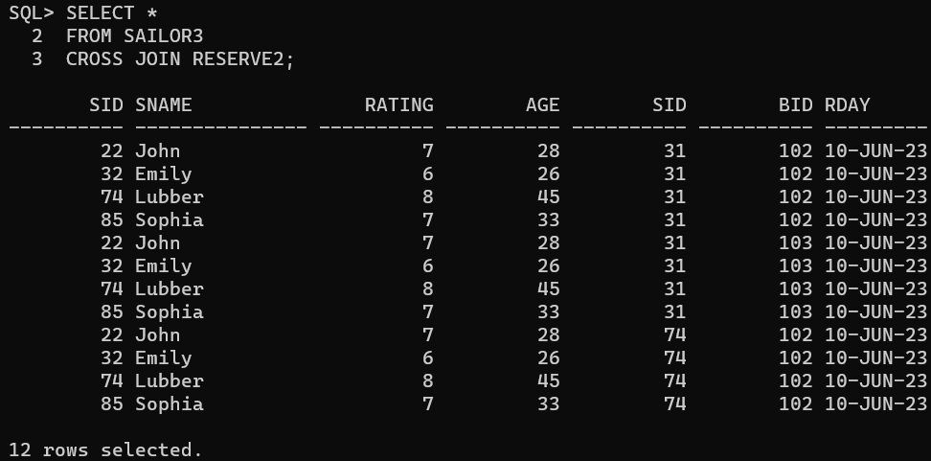

- Find the names of sailors who have reserved boat 103. [Perform using Natural Join and Inner Join]
NATURAL JOIN:
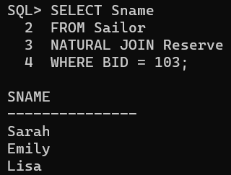
INNER JOIN:
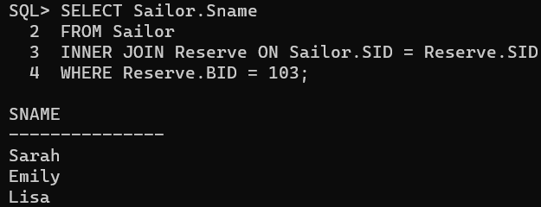

- Find the names of sailors who have reserved a red boat. [Perform using Natural Join and Inner Join]
NATURAL JOIN:
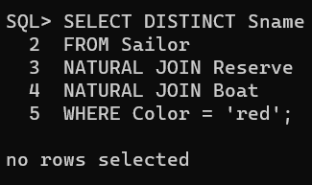
INNER JOIN:
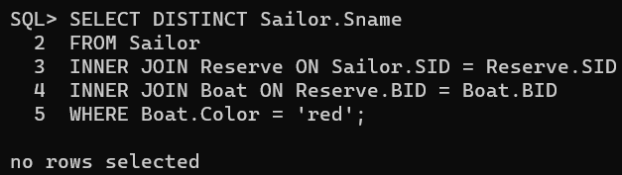

- Find the colors of boats reserved by Lubber
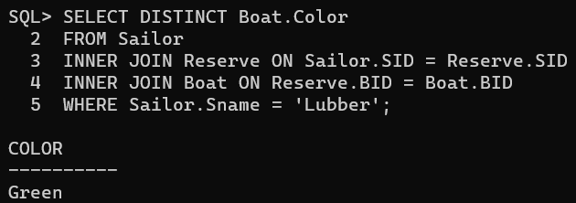

- Find the colors of boats reserved by Dustin
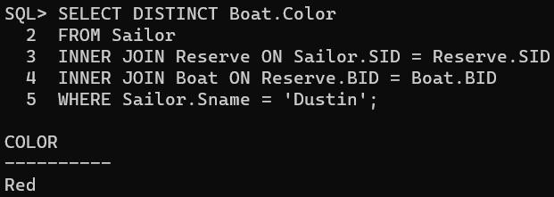

- Find the names of sailors who have reserved at least one boat.
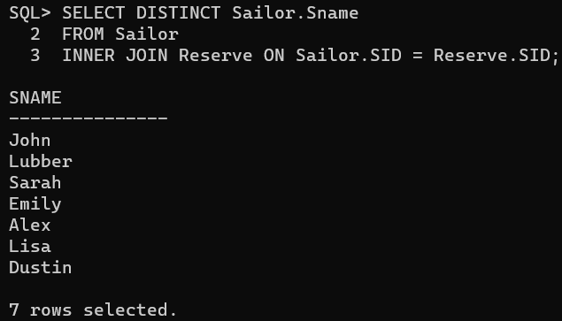

- Find the names of sailors who have reserved either a red or a green boat.
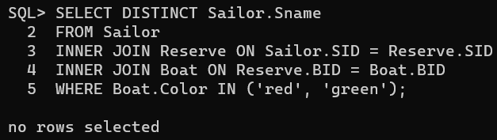

- Find the names of sailors who have reserved a red and a green boat.
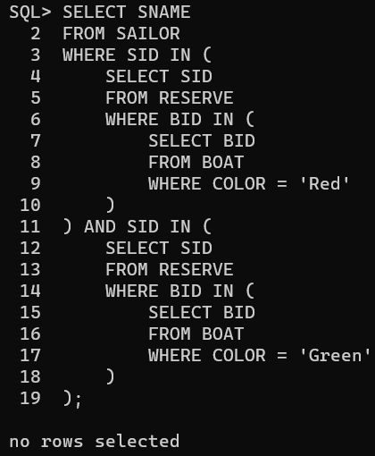
- Find all sailor id’s of sailors who have a rating of at least 8 or reserved boat 103.
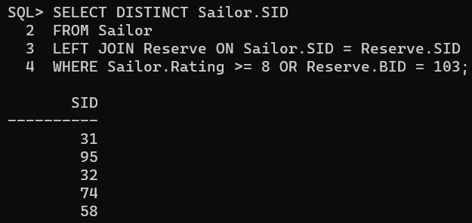

- Find the names of sailors who have reserved a boat whose name contains ‘U’ and Order the names in ascending order.
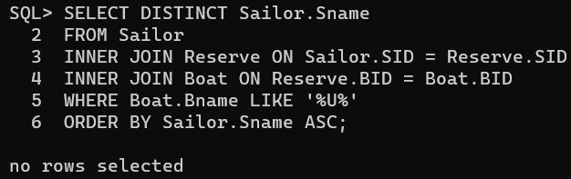

- Find the sailor id’s and name of sailors with age over 20 who have reserved a boat whose name includes the string “lake”.
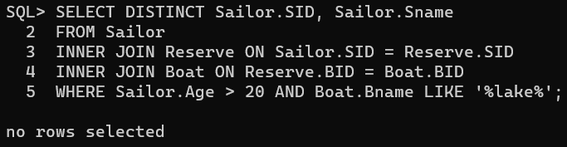

- Find the sailor id’s of sailors whose rating is better than some sailor called Bob
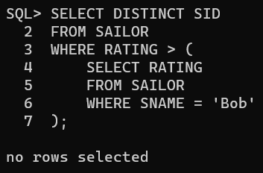

- For each boat which was reserved by at least 5 sailors with age >= 40, find the boat id and the average age of such sailors.
